Name_______________________________ Date_____________________________

DIY Jiànzi

Build Your Jiànzi

Your task is to create your own Jiànzi using feathers, threads, coins, etc.
 | Important: Success Criteria

Secure Feather Attachment: Feathers are firmly attached and arranged to help the Jiànzi spin well.

Can you gently flick or drop your Jiànzi without the feathers falling off or shifting?

Are the feathers spread out evenly and pointing upright to catch the air when it spins?

Balanced Weight: The weighted base is stable and balanced, keeping the Jiànzi flying smoothly.

Does your Jiànzi fly in a straight path and spin when kicked or dropped?

Is the base weight centered, with no parts sticking out or making it wobble?

Material Needed
Feather | Thread | Leather Strip | Plastic Tube
Coins | Leather Pad | Scissors

Steps to Build the Jiànzi
Follow the given steps to build your Jiànzi.
Step | Instructions
1 | Choose your base. Use a leather pad as the main base for your Jiànzi. Place a metal washer and 1–2 coins in the center to give it proper weight. This helps the Jiànzi stay balanced and fly upright. | 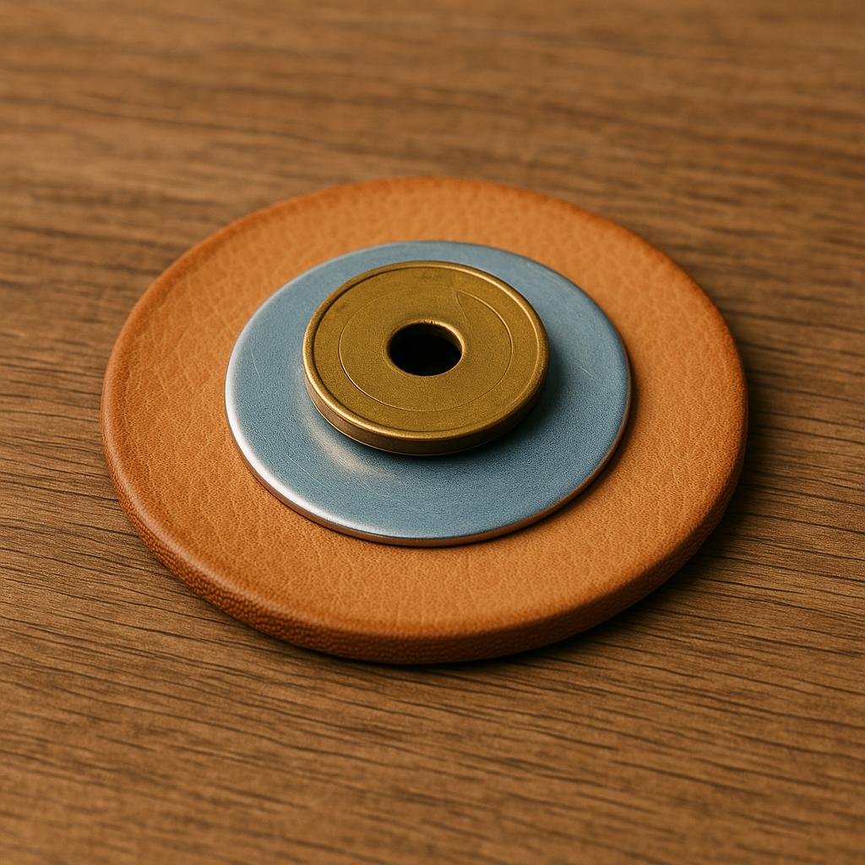
  IMPORTANT: A flat, sturdy cap helps the Jiànzi fly evenly — make sure it’s not wobbly.
   | THINK: Will adding weight make it fly straighter or fall faster?
2 | Use scissors to carefully cut a small slit or hole in the center of the leather pad. This is where the feathers will go. (If the leather pad already has a small slit, you can skip this step!) | 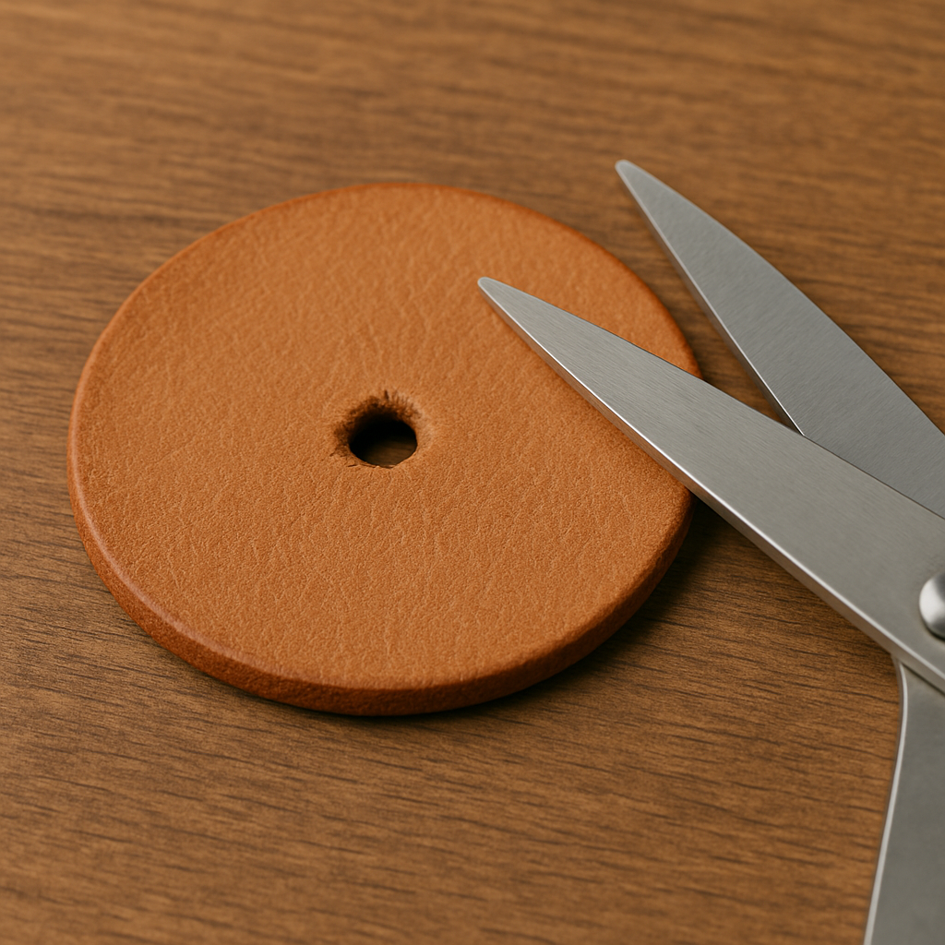
   | SAFETY: Ask for help when using a sharp object to poke holes; do not use too much force.
3 | Gather 3–6 rooster feathers and line up their ends neatly. Wrap thread tightly around the base of the feather bundle to hold them together. | 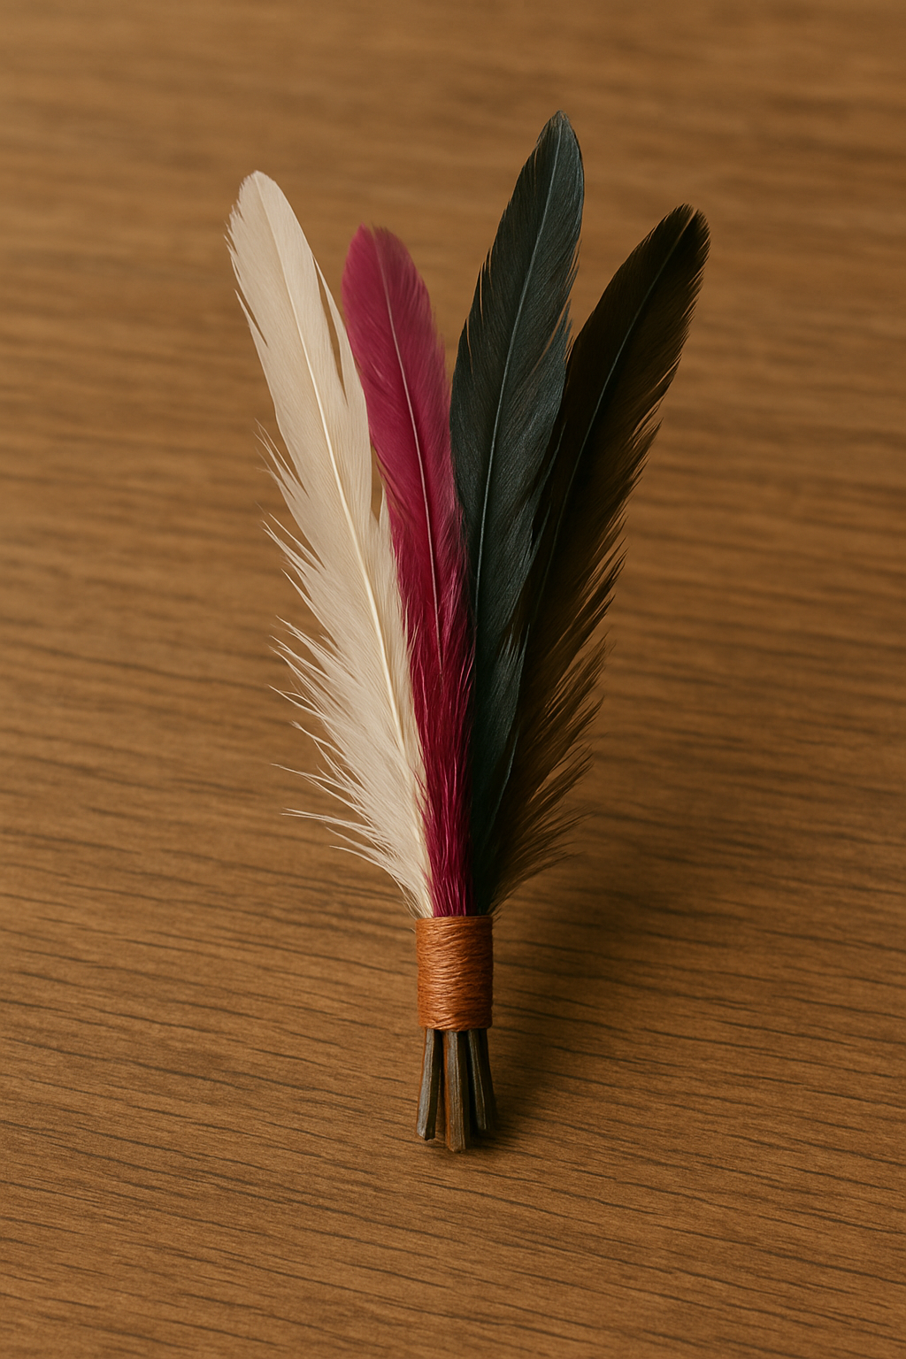
   | HINT: Loose feathers will wobble or fall off during kicks.
4 | Insert the feather bundle into the hole in the cap and secure it firmly with thread.  Slide a short plastic tube under the feather bundle to help keep it upright and add extra stability. Use the thread to hold this in place. | 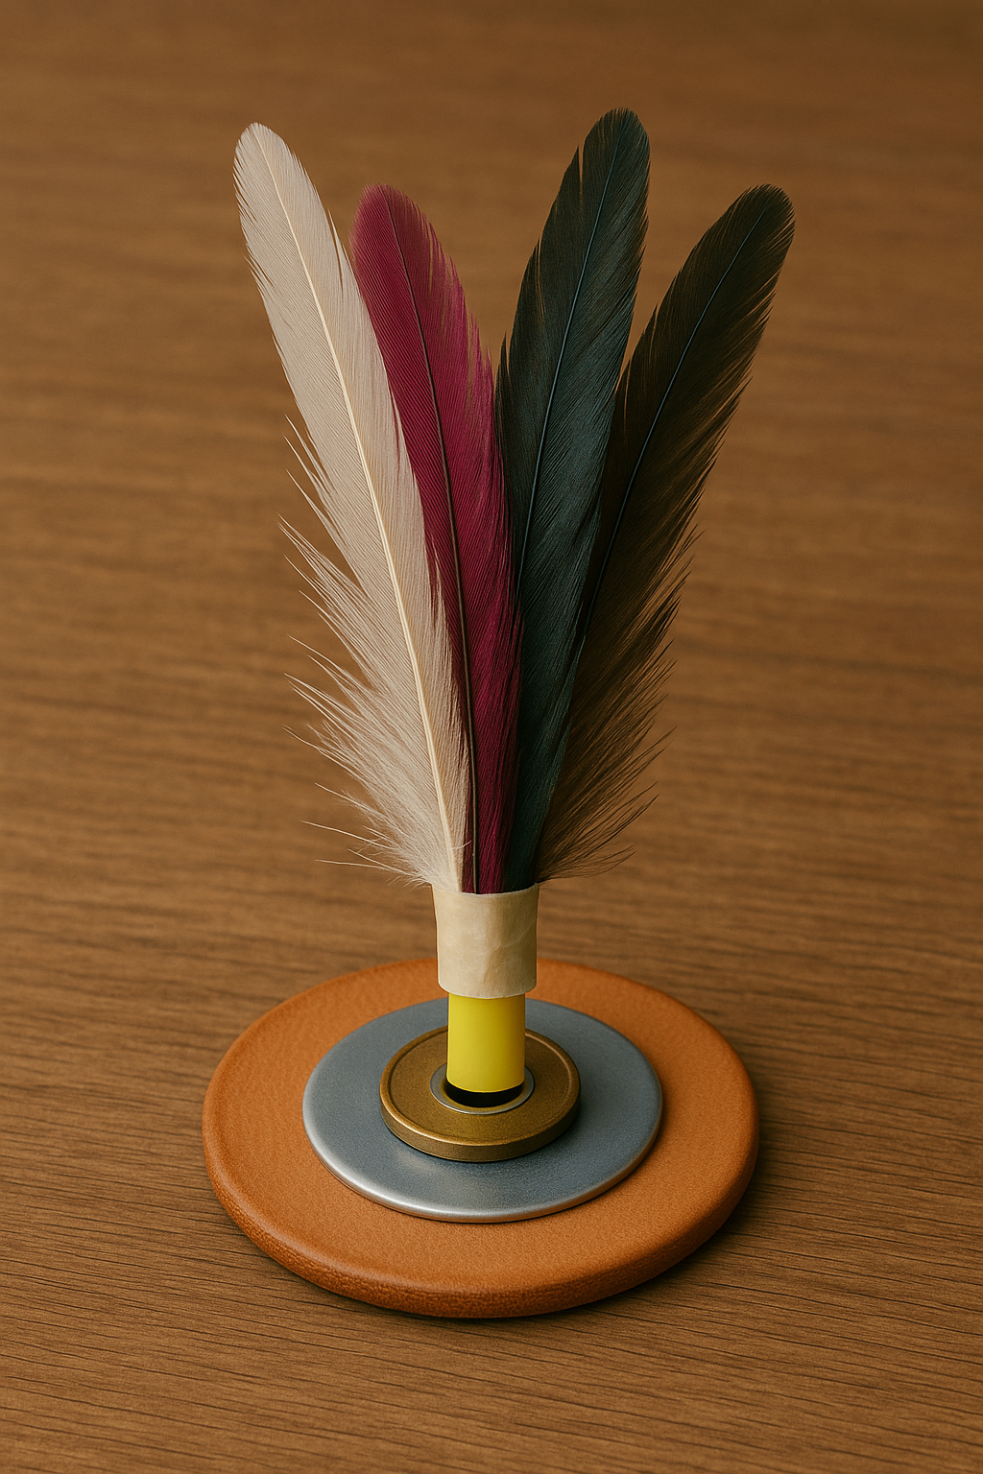
5 | Drop or gently kick your Jiànzi to observe whether it flies upright, spins, or falls sideways, and makes small adjustments to the feathers, weight, or loose parts as needed.
6 | Decorate your Jiànzi with colored leather strips or extra feathers. Make it reflect your style, but keep it light so it still flies well. | 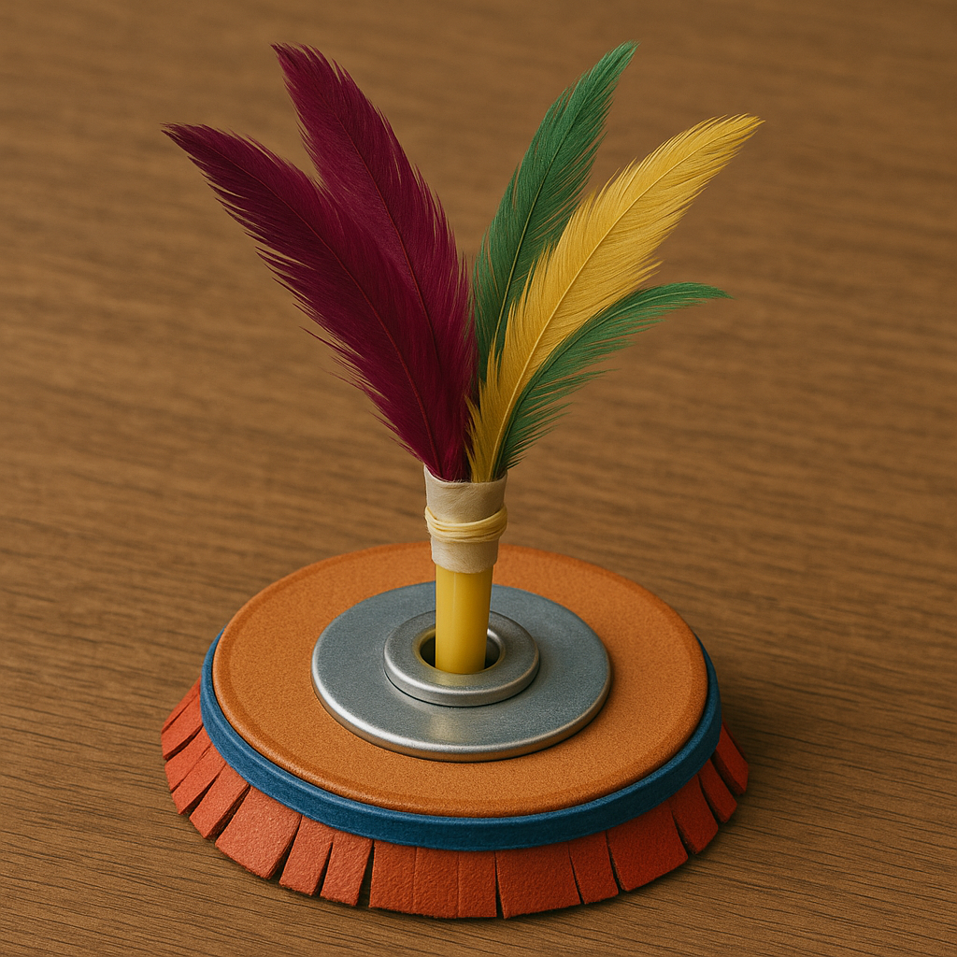
  HINT: Lighter decoration material won’t affect flight much.
7 | Give your Jiànzi a name and personality (‘Sky Spinner’, ‘Fire Feather’, etc.)
  THINK: What kind of personality does your Jiànzi have — bold, fast, wild, or calm?
8 | You can choose your Jiànzi design level and tweak it as well.  - Basic: One coin and a simple feather bundle, which is light and easy to start with.  - Intermediate: Use two coins for better balance. Add 5–7 rooster feathers.  - Advanced: Use a leather pad + folded leather strip base, add a plastic tube stabilizer, and shape or design it for extra spin and style.  You can also start simple. You can always level up your design once it flies well. | 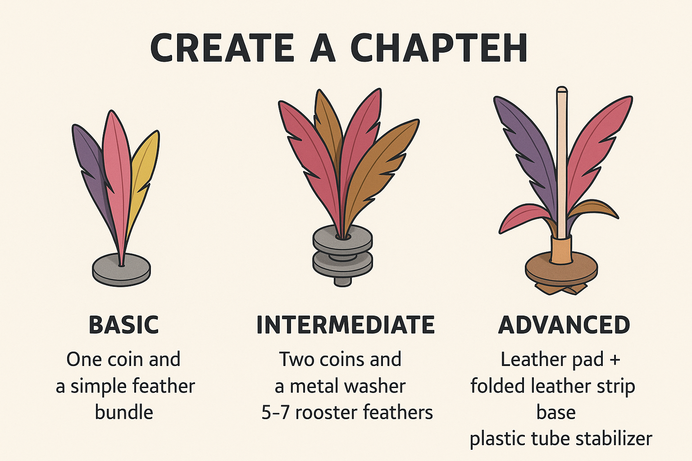

Test the Jiànzi
- Find a partner.
- Each person gets a different Jiànzi (with different weights or feather designs).
- Take turns to kick your Jiànzi once.
- Time how long it stays in the air (use a stopwatch or count).
- Watch how it moves – does it spin, wobble, glide, or fall fast?
- Write down your results in the table.
- Think of one way to improve your Jiànzi.
Jiànzi | How many coins? | How many feathers? | Time in air (seconds) | Flew well? (Yes/No) | One way to improve it
A
B

Follow the given suggestions to improve the design of your Jiànzi:

Try using fewer coins to make it lighter.
- Add more feathers to help it glide better.
- Ensure the feathers are spread out evenly to maintain balance.
- Try spinning it when you kick to keep it steady in the air.

Jiànzi: Tips and Mistakes
TIPS | COMMON MISTAKES
Throw it up and down: Toss the Jianzi straight into the air with your hands to get a feel for its motion and timing. | Kicking with your toes like in football: This causes the Jianzi to fly unpredictably. Use the inside or outside of your foot instead for more control.
Keep staring: Maintain eye contact with the Jianzi at all times to track its path and improve control.
Either kick from inside or outside of the feet: Choose one side of the foot to practice with first—either the inside or the outside—for better accuracy and consistency. | No rest for your kicking foot: Constant motion without resting can throw off your rhythm. It’s okay to pause, reset, and focus on technique.

3-2-1 Reflection

3 Things I Noticed While Playing Jiànzi:
(E.g., I used different parts of my foot to kick, I had to balance my body while kicking, etc.)

2 Things I Improved On Today:
(E.g., I kicked more times in a row, I stood more steadily or balanced better, etc.

1 Question I Still Have About Jiànzi:
(E.g., What materials can I use to make my own Jiànzi at home?)

